# Manage Terms to Members.

As for Manage Files – the Manage Terms module should be as below.

**Please note that the fields are a bit different.**

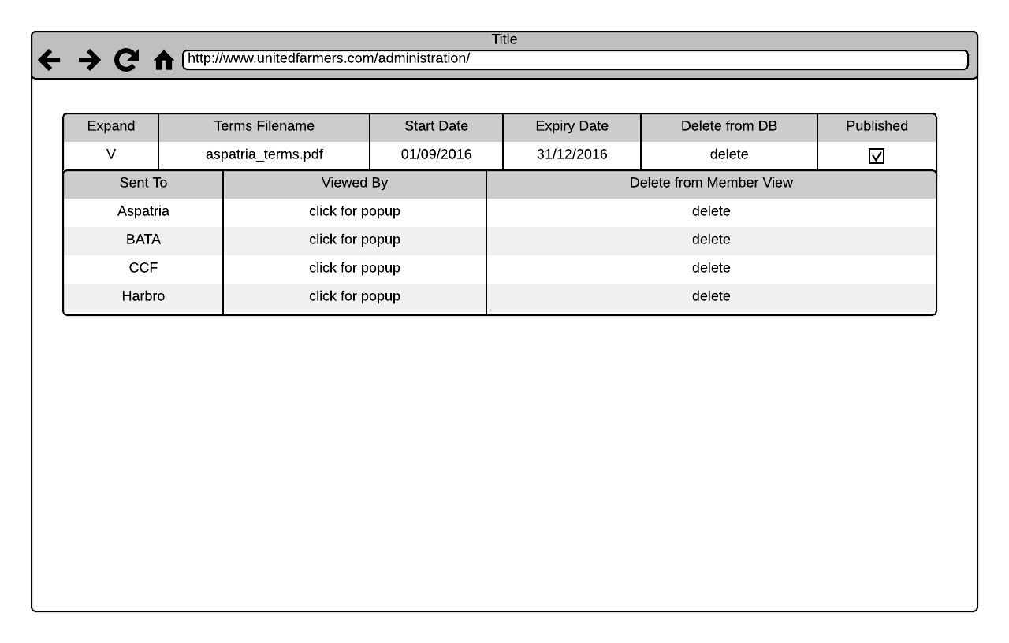

The, when the user clicks the expand arrow/link in column one, we see the list of members that these terms have been sent to (as we do with files) and then a popup to show which users have viewed them (as we do with files)

**Add Supplier Name as another column. Should be split into TWO sections :**

**Table 1 : Unpublished : Listed in upload date order, newest first.**

**Table 2 : Published Terms : Listed in order of Supplier (alphabetical)**

# Upload Terms to Members

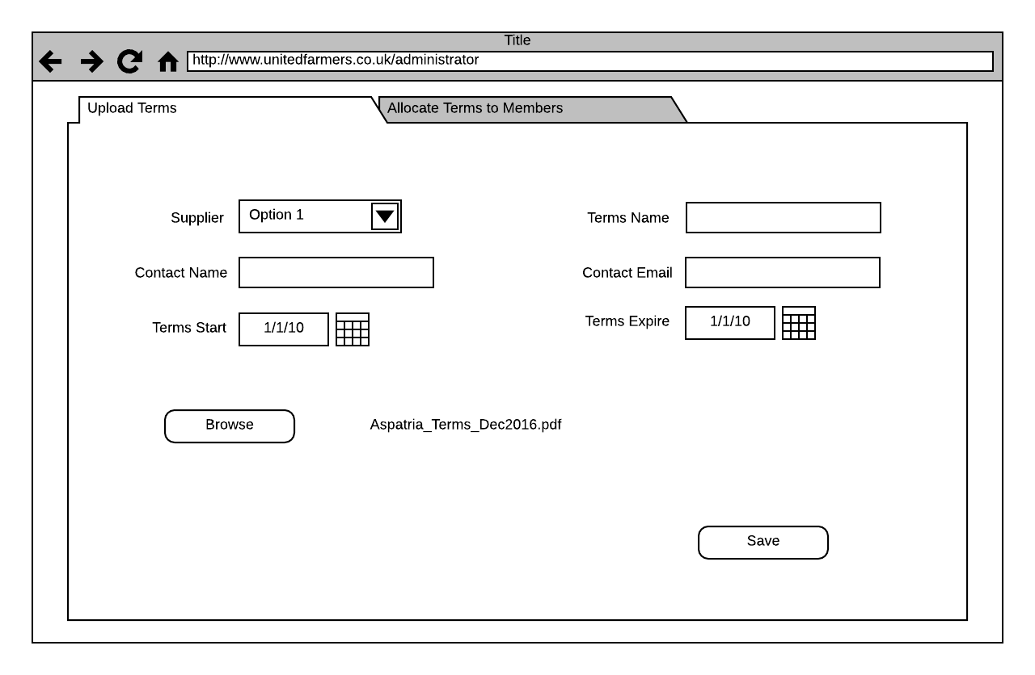

So, to upload terms files, select the supplier on who’s behalf the terms are being added.

Add a name for the terms, the Contact Name and email address for the terms and the valid date range (start / expiry) for the terms.

**\*\* Contact Name should be a dropdown of all ‘Confidential’ users for the supplier that has been selected**

Browse for the PDF file on your computer (once you select a file you will see it on the screen)

If you select the wrong file, you should be able to delete it (with a x like we have in send terms at the moment)

Hit save and the PDF is uploaded and stored with the information you entered.

**\*\* It should then show up in the Manage Terms view – but SHOULD NOT BE PUBLISHED until admin ticks the tickbox.**

# Allocate Terms to Members

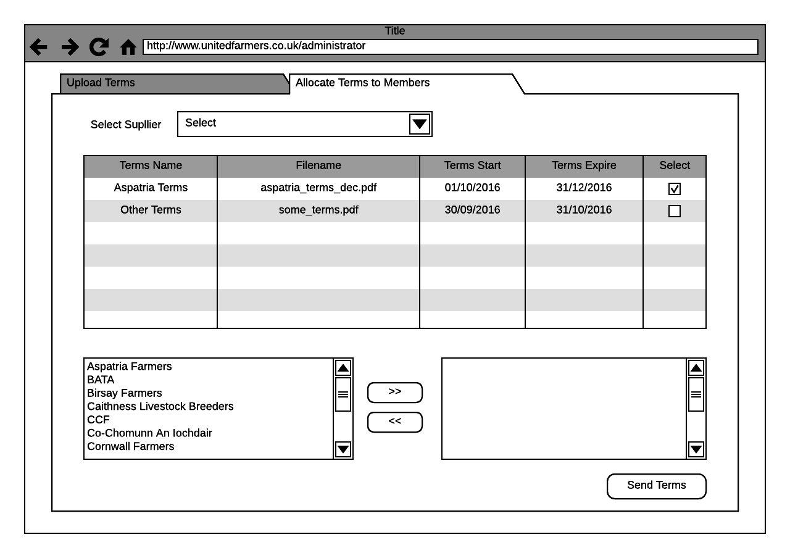

Once you have uploaded terms you can select the Allocate Terms to Members tab.

Here you can select the supplier (the tab will default to the supplier you selected in the Upload Terms tab unless you did not select one (you may be returning to the page just to send some terms and not be uploading any)

You will then see all of the terms files that have been uploaded for that Supplier in the table.

You can select which member(s) to send these terms to with the bi-directional select boxes (the same way it works now in Send Terms).

Once you have selected which terms (by checking the check box in the table) and which members (by selecting them in the boxes below the table) you hit Send Terms to distribute these terms to the members.